**● Explain and perform Importing table contents from Mysql to Hive using Sqoop.**

Creating a table sample and inserting values into it in MYSQL:

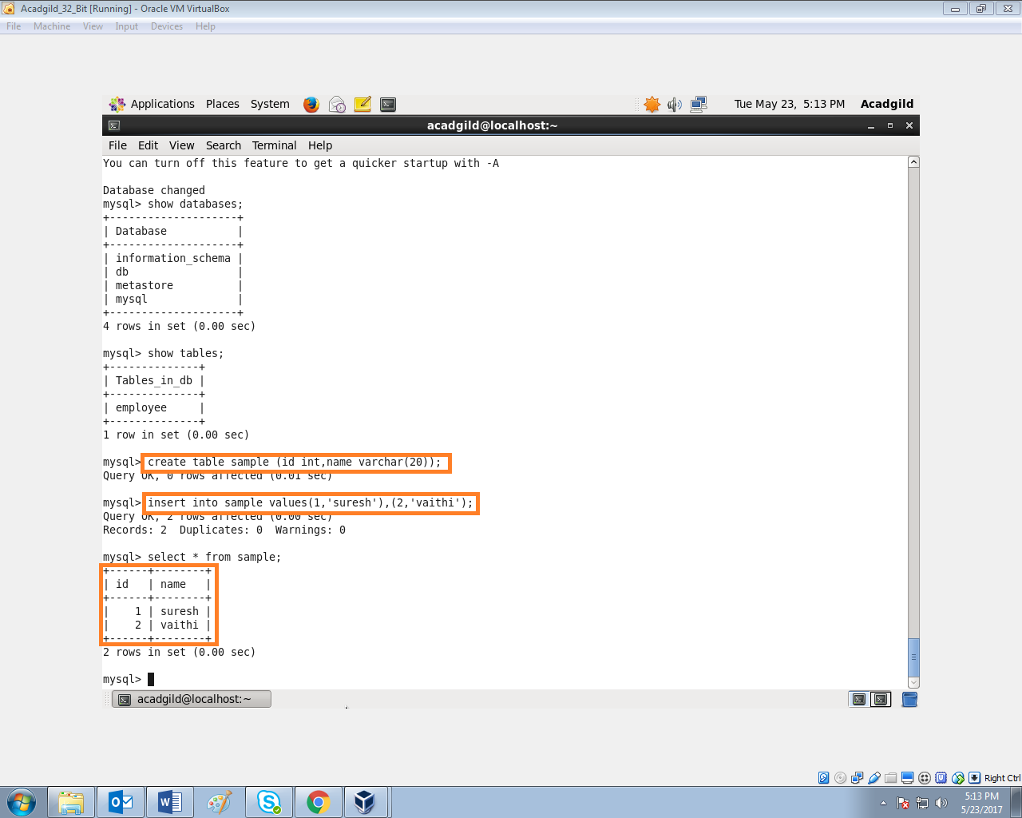

Importing the data from mysql to hive using SQOOP:

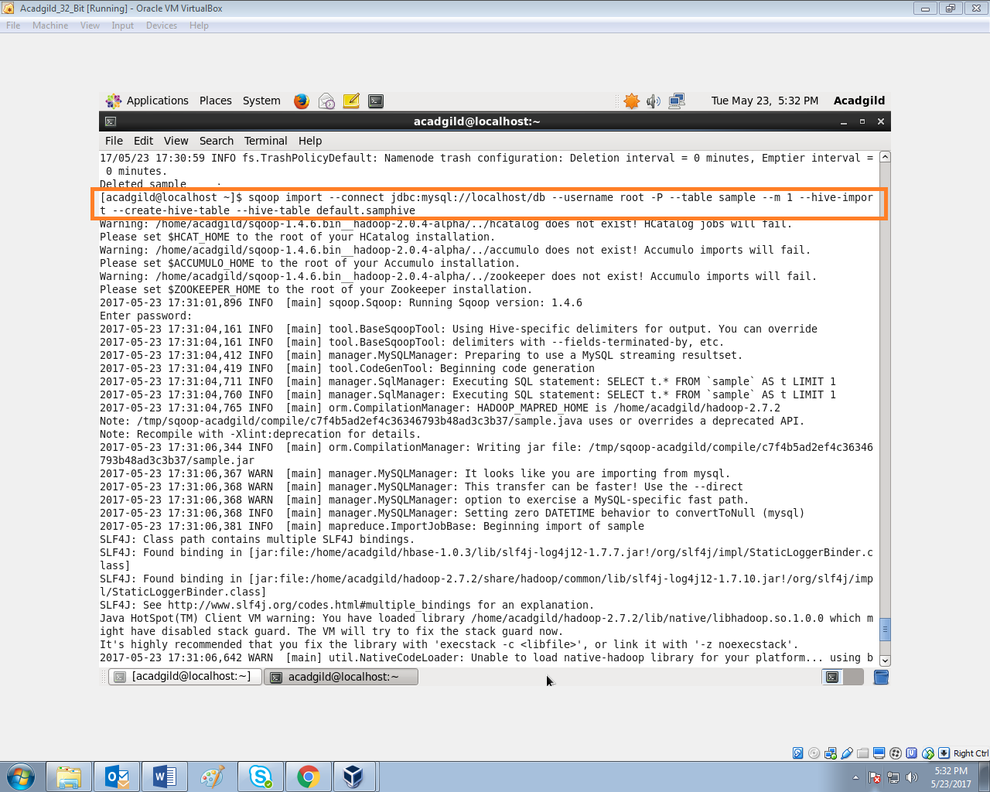

Data imported successfully:

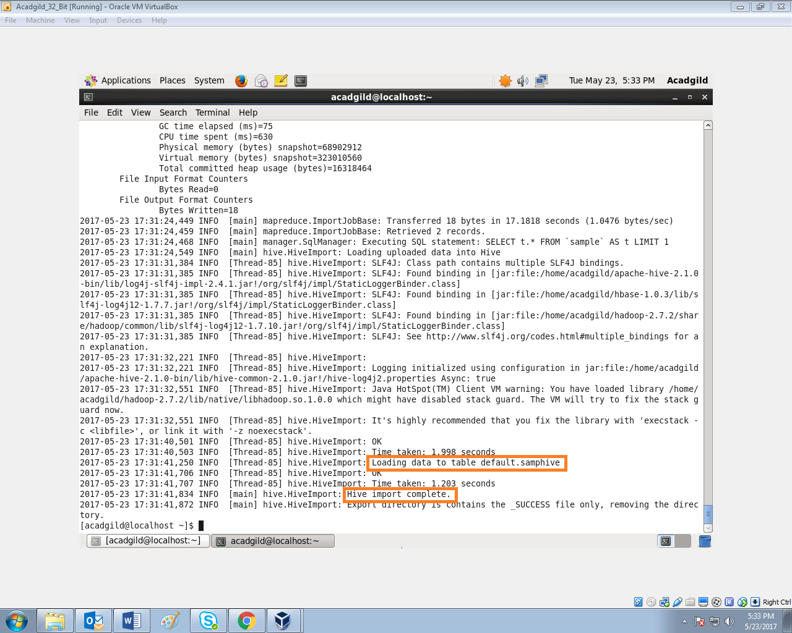

Displaying the data in hive which is imported from mysql:

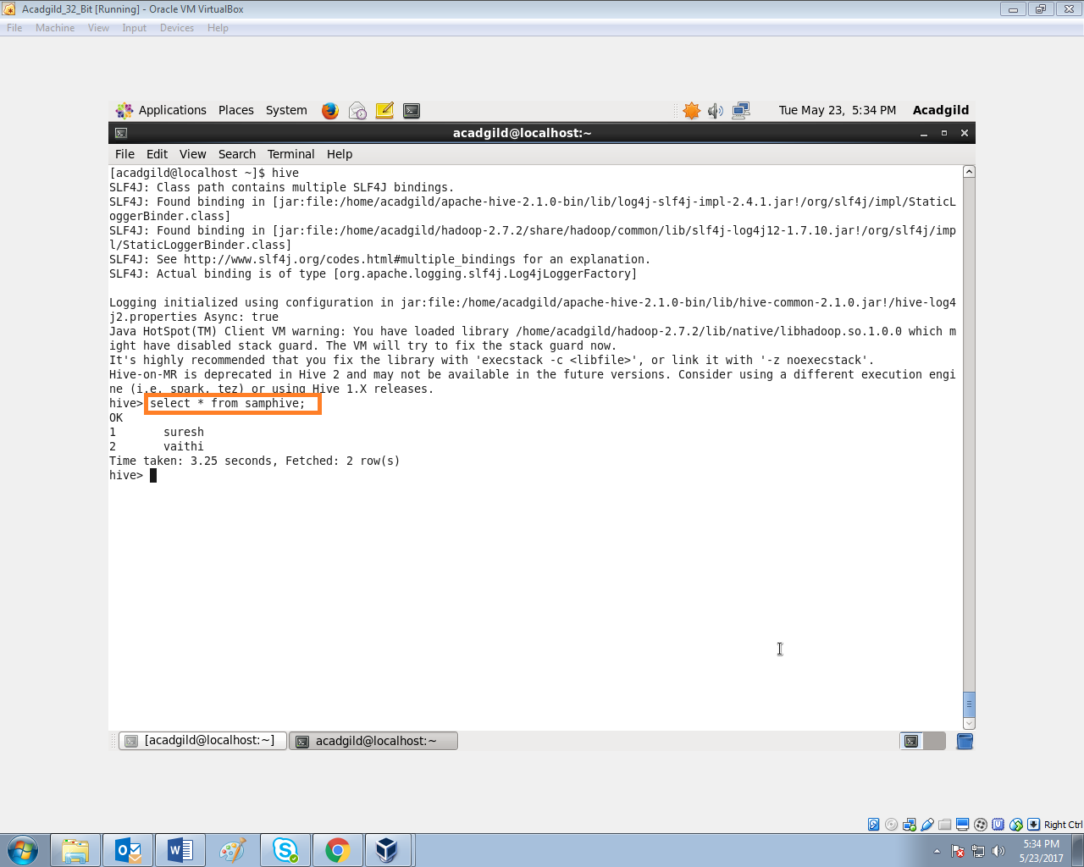

**● Explain and perform Importing table contents from Mysql to HBase using Sqoop**

Creating a table samplehb with ‘details’ as column family in hbase:

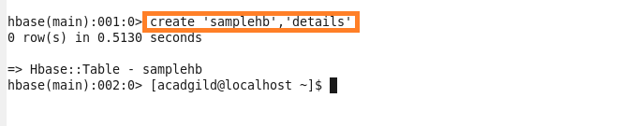

Importing the data from mysql to hbase:

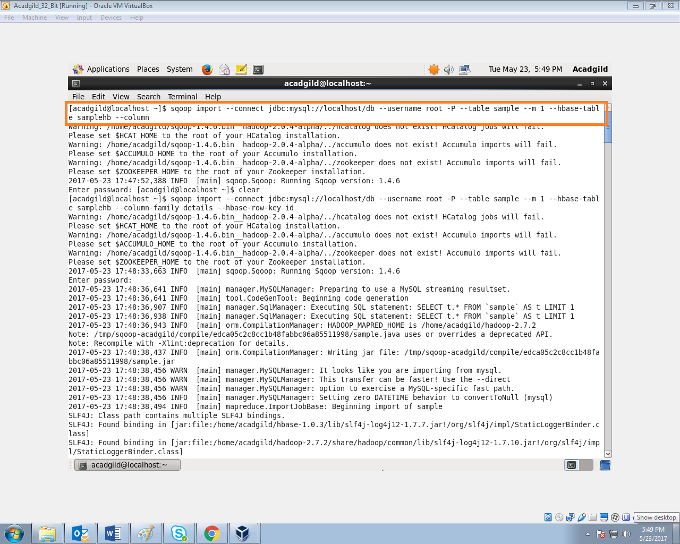

Data imported successfully:

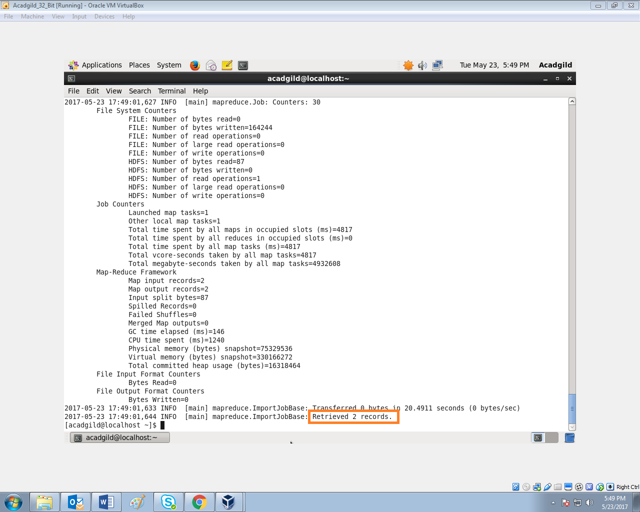

Displaying the data in hbase which is imported from the mysql:

